Soldering station

|  |  |
| --- | --- |
| Author | Dries Nuttin |

Content

1 Introduction 1

2 Material and methods 2

3 Results 3

3.1 Functionality and device overview 3

3.2 Device overview 3

3.2.1 Electrical schematic and PCB design 3

3.2.2 Mechanical design and Final product 3

4 Discussion 4

5 References 4

# Introduction

The aim of this project was to create a functional soldering station, which would in turn provide a valuable learning experience regarding the production of a PCB (Printed circuit board) and 3D modelling. The idea was first introduced by the catalogue Elektor (ElektorMAG, 2021). This meant that there was already a solid foundation to start building the soldering station from, which allowed the focus of the project to be more towards learning new software and building tools and less towards trying to make something from scratch. The finished product would also be useful in the years to come as it is an essential tool in the hands of an electrical engineer. This paper will explain the step-by-step process of embarking on a first real project, the issues along the way, and the revelations.

# Material and methods

The manufacturing of the soldering station involves the collaboration of five distinct modules, each serving a specific purpose. Firstly, the power supply module assumes the responsibility of providing power to the entire PCB, ensuring its smooth operation. It serves as the foundation for the station’s functionality. Secondly, the CPU module, akin to the station’s central nervous system, which provides the necessary brain power and supervises the overall performance of the soldering station.

The third module in line is the PWM module, essential for generating and controlling the required heat for efficient soldering. It regulates the temperature of the soldering iron, optimizing its performance. The fourth module, the thermocouple, plays the role of measuring and adjusting the temperature of the soldering iron, ensuring precision and reliability. Finally, the fifth module is the display, which offers a user-friendly interface to monitor the temperature of the soldering iron which makes using the soldering station a lot easier.

The schematic provided was closely reproduced and refined using Altium software, with a few minor alterations. Employing Altium meant seamless design modifications and an easy conversion of the schematic into a real PCB. Furthermore, a detailed Bill of Materials (BOM) guided the design, enabling bulk purchases of the required components. Collaboration with fellow classmates streamlined the purchase, ensuring a smooth and efficient way to acquire the necessary components. Below you will find the full BOM used in this project.



It is important to acknowledge that the PCB itself does not qualify as a final product. To enhance functionality and user experience, a well-designed and ergonomically sound case is necessary. The case design process was executed within Fusion software. The final design ended up being a case which resembled an old arcade machine. This design made sure that there was enough space for the PCB to be placed and for the transformer to rest at the bottom of the case. Fusion software was selected purposefully, owing to its compatibility with slicer applications, facilitating the efficient conversion of the case design into a 3D-printable format.

Once the final PCB design was finished, it was possibly to fabricate this PCB with the collaboration of an external manufacturing company, JCLPCB (jlcpcb, n.d.). This was done to ensure a faultless and optimal manufacturing process, minimizing the risk of errors or malfunctions. Once all the components were acquired and the PCB finished production, the assembly process could start. By using a silk screen to place all the smaller components and hand soldering the bigger components, there was a smaller chance of any short-circuits presenting themselves in the design. Following the assembly process, a full inspection of the PCB was conducted to detect and remove and short-circuits and imperfections. The microcontroller was fully programmed and the PCB was connected to a dynamic power input. The voltage was gradually increased until reaching the desired output voltage of approximately 230 Volts. Successful completion of this testing phase ensured the readiness for the final stage of production.

The final stage of the design was the assembly of all components, including the case and the soldering iron itself. This final stage resulted in the full realization of a fully functional and aesthetically appealing soldering station.

# Results

The manufacturing process of the soldering station yielded valuable insights and outcomes. However, it is important to note that despite a long inspection of the PCB, a minor short circuit in the microcontroller resulted in an excessive current flow through the circuit, leading to its failure. This unexpected occurrence highlights the significance of thorough inspections and reinforces the need for meticulous attention to detail in future iterations. Due to a lack of time until the final deadline it was not possible to redesign and order a new PCB which caused this project to fail.

## Functionality and device overview

The soldering station, as envisioned, encompasses five distinct modules, each serving a specific function. These modules include the power supply, CPU, PWM, thermocouple, and display. The power supply module delivers power to the entire PCB, acting as the foundation for its operation. The CPU module acts as the brain of the system, overseeing its overall functionality. The PWM module controls the heat supplied to the soldering iron, while the thermocouple module regulates its temperature. Lastly, the display module provides users with clear visibility of the soldering iron’s temperature.

Despite encountering an issue with the PCB, the device’s intended functionality was designed to deliver precise and efficient soldering capabilities. It is important to highlight that while the specific details of the device’s operation cannot be realized due to the setback encountered, the initial design aimed to provide users with a reliable soldering experience.

## Device overview

### Electrical schematic and PCB design

The electrical schematic and PCB design were meticulously developed using Altium software. The schematic captured the intricate connections and relationships between the various modules, ensuring proper functionality. The PCB design involved carefully positioning the components and traces to maximize performance and efficiency. Unfortunately, due to the encountered short circuit, the PCB did not meet the expected standards, emphasizing the need for enhanced inspection and improved design iterations.

The PCB itself and the full schematic can be found in the picture below.

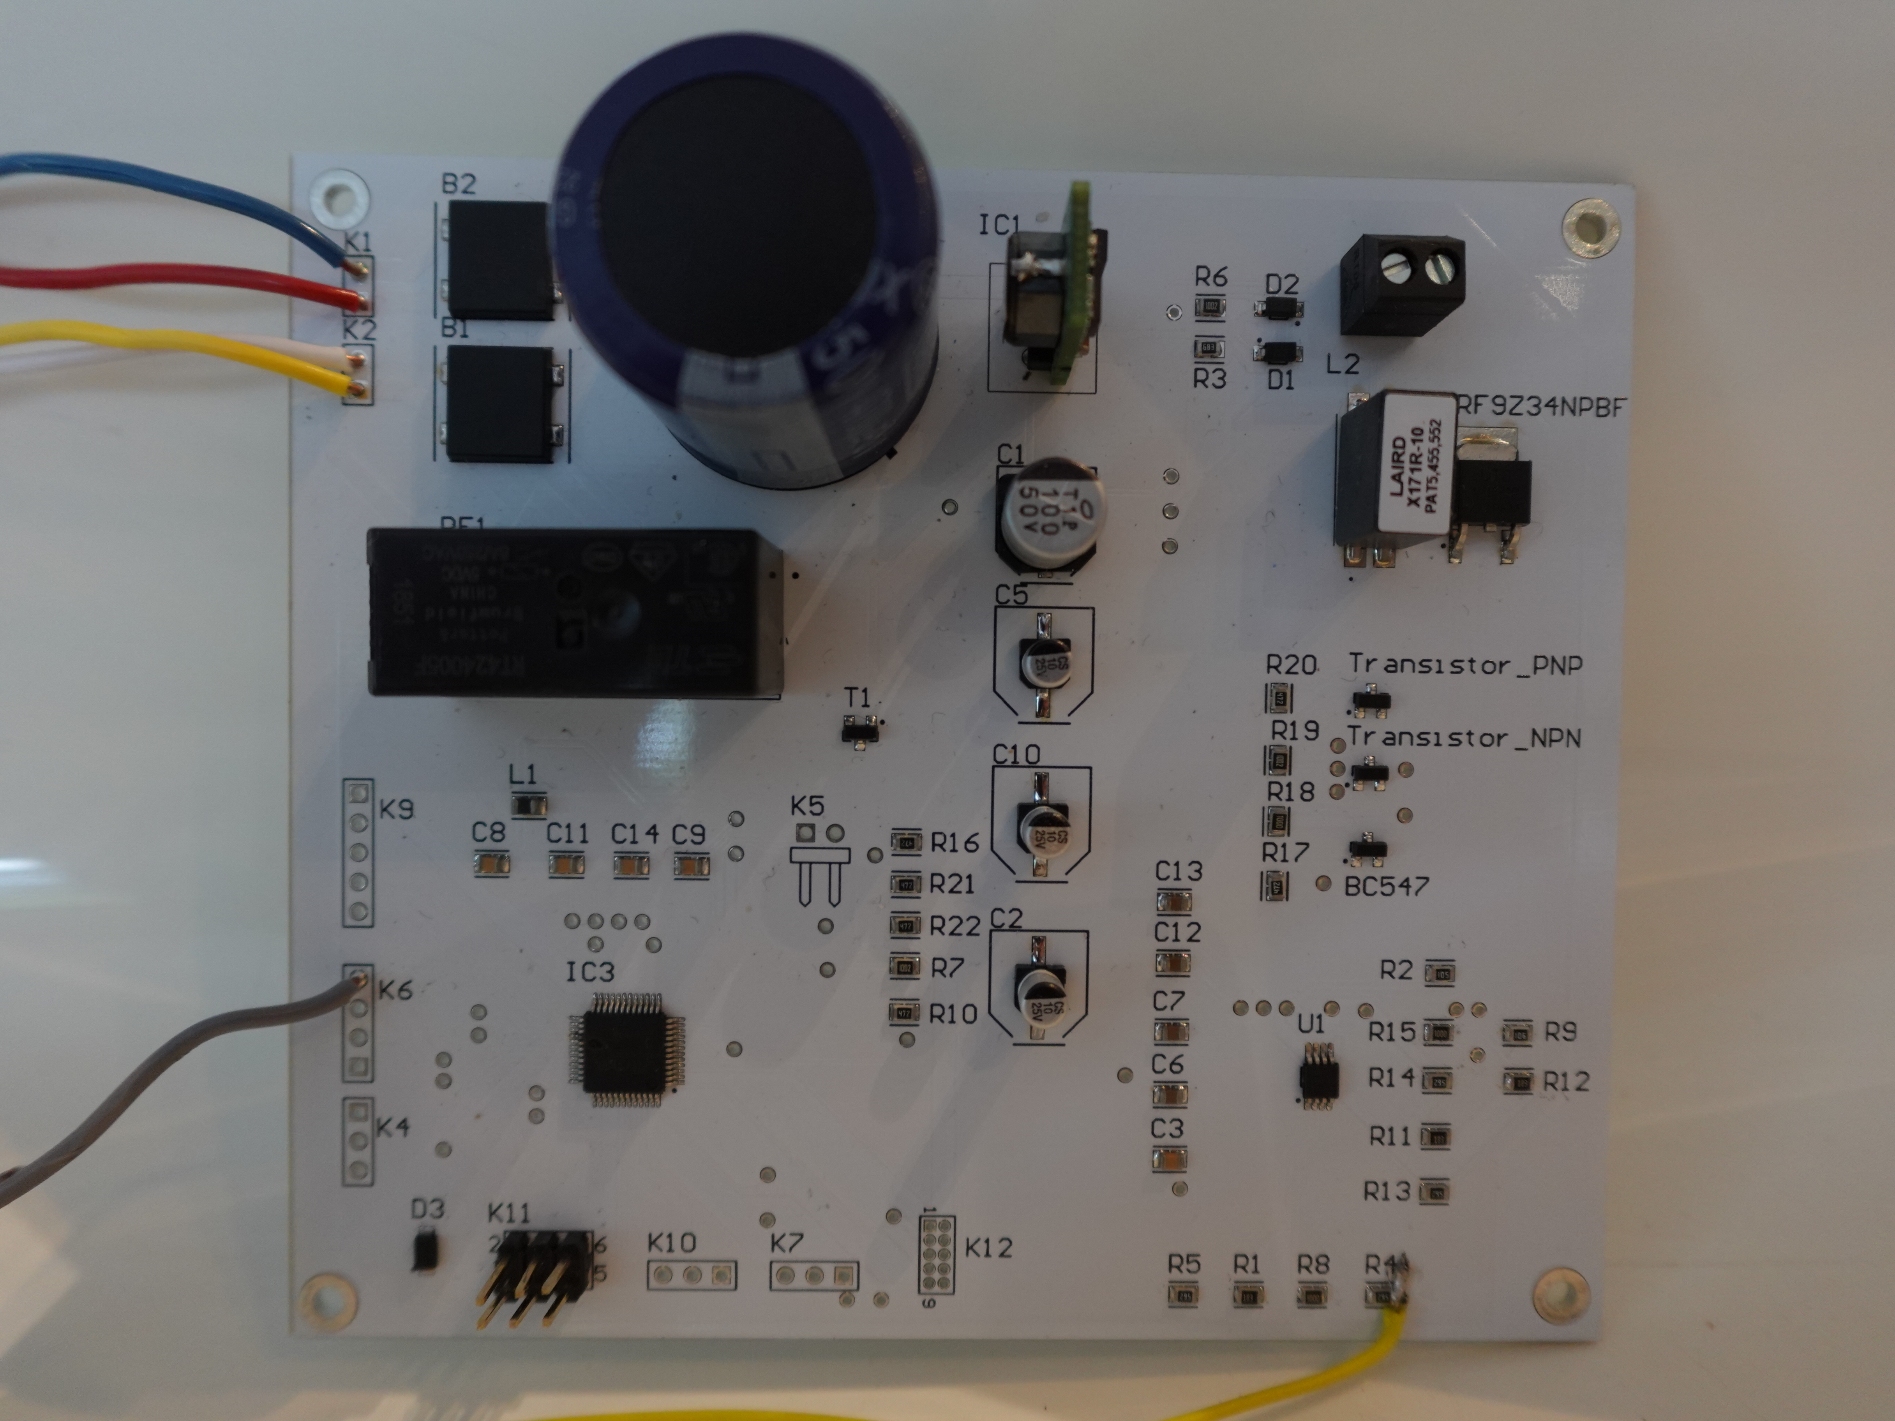

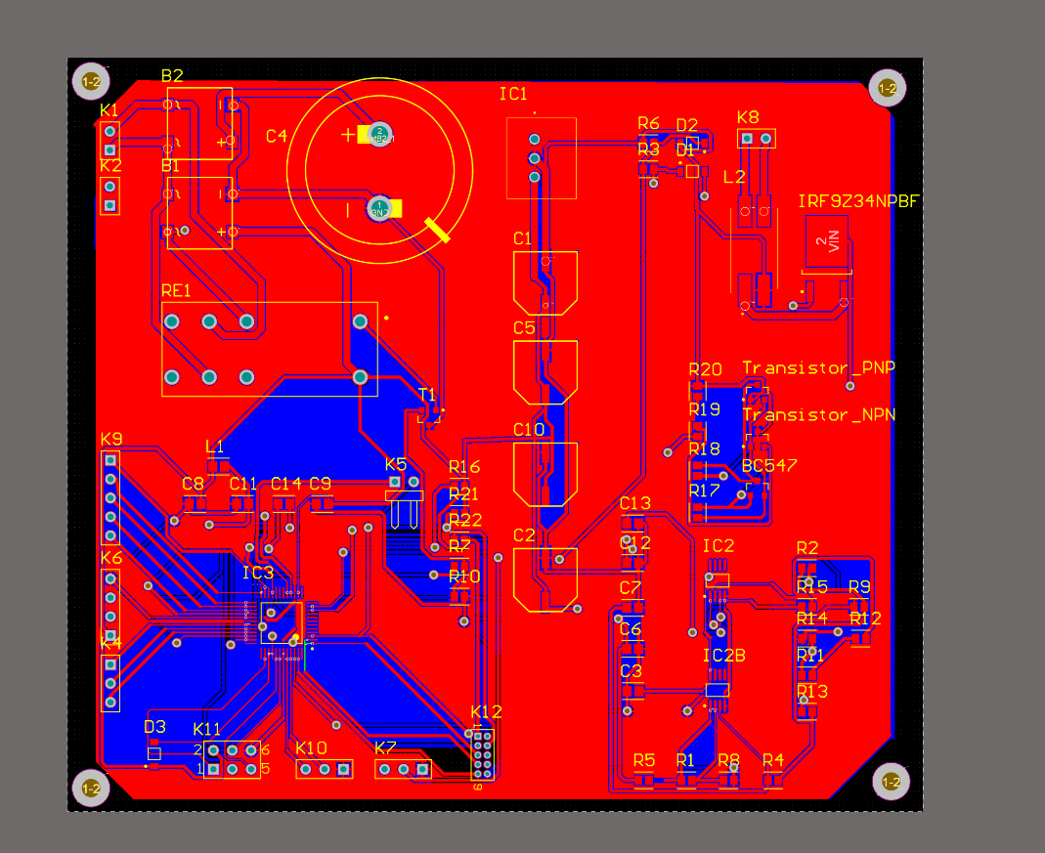ssss

### Mechanical design and Final product

The mechanical design of the soldering station aimed to strike a balance between functionality and aesthetics. The finalized design, resembling an old arcade machine, provided ample space for housing the PCB, transformer and LCD screen. Additionally, it presented an appealing exterior, blending form with function. The mechanical design was developed within Fusion, ensuring a clean integration with the overall device design and compatibility with 3D printing technologies.

Despite the setback encountered during the manufacturing process, the potential of the soldering station as an efficient and user-friendly device remains evident. The device’s intended functionality and design elements lay the foundation for future improvements and iterations. The fact that the PCB failed to work reinforces the importance of thorough inspections, rigorous testing, and continual adjustments to the design to ensure the development of a reliable soldering station.

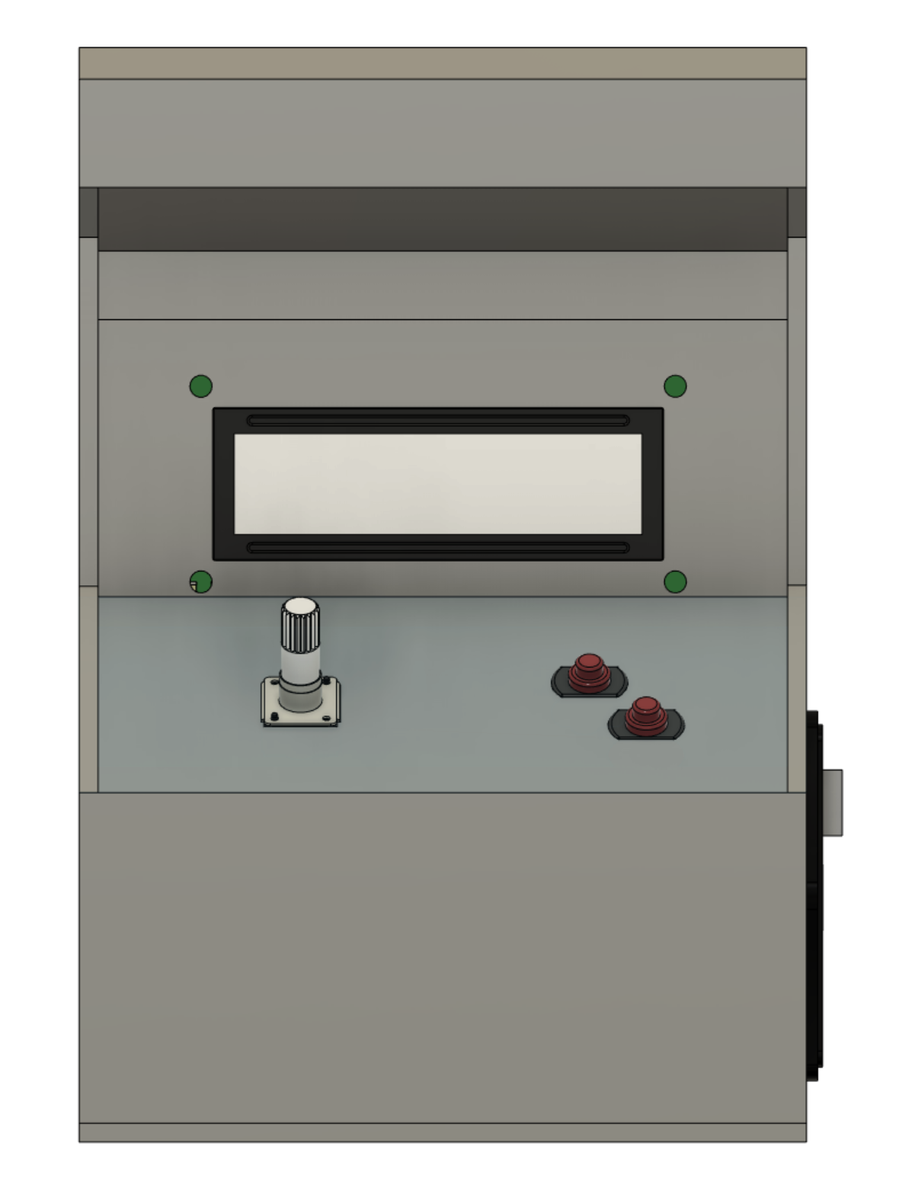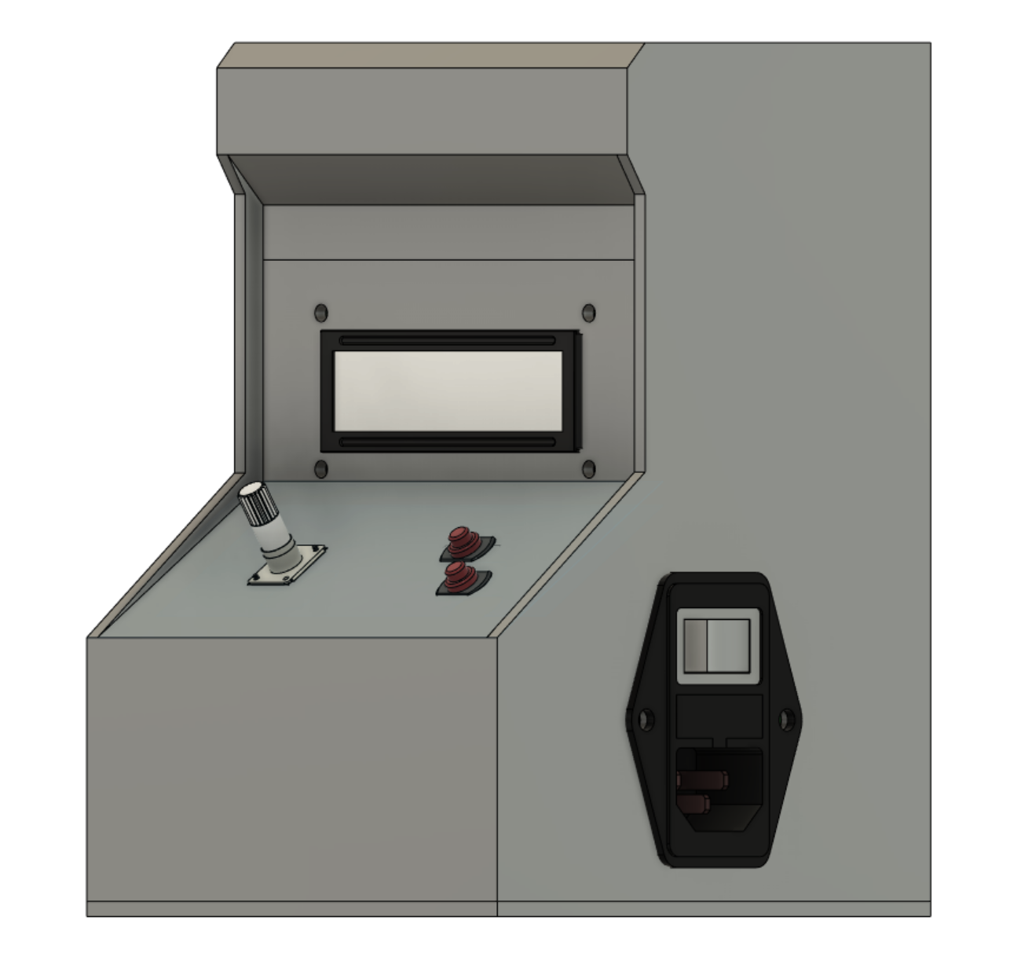

# Discussion

During the design process of the soldering station there were multiple issues that were each handled semi-professionally. Due to budgetary restrictions and time restrictions, it was not possible to fully redesign the mistakes made during the design process. This made it necessary for a sometimes DIY design iteration, such as soldering a wire to the end of a resistor. Because of the aforementioned restrictions it was not possible to do these iterations professionally like buying a new PCB. In future projects it would be necessary to have a more fleshed-out testing process in the beginning of the project itself, to ensure that all the components are right. Choosing the right components and knowing what role each of them plays was the main setback in the beginning of the project. It is invaluable to gain a full understanding of the underlying function of each component.

Throughout the evaluation phase, multiple mistakes were found and all handled correctly. Identifying mistakes like these is an expected part of the initial design development, and as previously discussed, the design could have gained significantly from less restrictions. One of these mistakes was that of a connected not being present in the PCB to measure temperature, which had to be soldered to one of the resistors after the fact. Another mistake was that of two 2x6 headers being the wrong footprint. These mistakes could be easily resolved in later iterations of the design.

Overall, the experiences and lessons learned from this project have equipped me with a stronger foundation for projects. The acquired knowledge, coupled with the ability to learn from setbacks, and the newfound knowledge of using Altium and Fusion will undoubtedly contribute to more refined designs, improved problem-solving skills, and ultimately, better outcomes in upcoming projects.

# References

ElektorMAG. (2021, 5). DHZ soldeer-station. *Elektor*, p. 116.

jlcpcb. (sd). Opgehaald van jlcpcb: https://jlcpcb.com/?from=VGB&gad=1